# Individual Project

Name: Cheng Zhiyuan

## Introduction

Computers are important production and entertainment tools today, and laptop products are loved by people for their portability in work and study. Based on its dual high added value of technology and application scenarios, the value volume of the laptop market cannot be ignored. This article will conduct a visual analysis of the laptop product market as the research object. I hope to provide some assistance in understanding market conditions and consumer product selection.

In this process, I will use Python, R, and Tableau for data processing and visualization analysis.

## Data Introduction and Processing

### 1.Data set introduction

The dataset used in this article is from the Kaggle website. (link: [Laptop Price](https://www.kaggle.com/datasets/muhammetvarl/laptop-price))

There are 1303 pieces of data in the dataset containing 12 variables:

|  |  |  |  |
| --- | --- | --- | --- |
| Variable Name | Type | Explanation | Example |
| Company | string | Laptop Manufacturer | Apple |
| Product | string | Brand and Model | Macbook Pro |
| TypeName | string | Laptop Type | Ultrabook |
| Inches | numeric | Screen Size | 13.3 |
| ScreenResolution | string | Screen Resolution | IPS Panel Retina Display 2560x1600 |
| CPU | string | Central Processing Unit | Intel Core i5 2.3GHz |
| Ram | string | Laptop RAM | 8GB |
| Memory | string | Hard Disk/SSD Memory | 128GB SSD |
| GPU | string | Graphics Processing Units | Intel Iris Plus Graphics 640 |
| OpSys | string | Operation System | macOS |
| Weight | string | Laptop Weight | 1.37kg |
| Price | numeric | Price (Euro) | 1339.69 |

### 2.Data cleaning

Given that multiple variables have the problem of high information complexity leading to too many types of elements, mainly carried out data cleaning work in two aspects.

* variables separation:

Separate the manufacturer from the CPU variable as a new variable. Divide storage variables into storage size and storage hardware type. Divide screen variables into panel type and resolution.

* Quantitative rating:

Classify the CPU and GPU variables based on their performance, with a maximum score of 5 and a minimum score of 1.

Other operations include converting 'Weight' into numerical data for subsequent analysis.

## Visualization Analysis

### Analysis from the Brand

Given the significant differences between workstation type laptops and personal laptops, and their relatively independent markets, we will exclude them from our analysis.

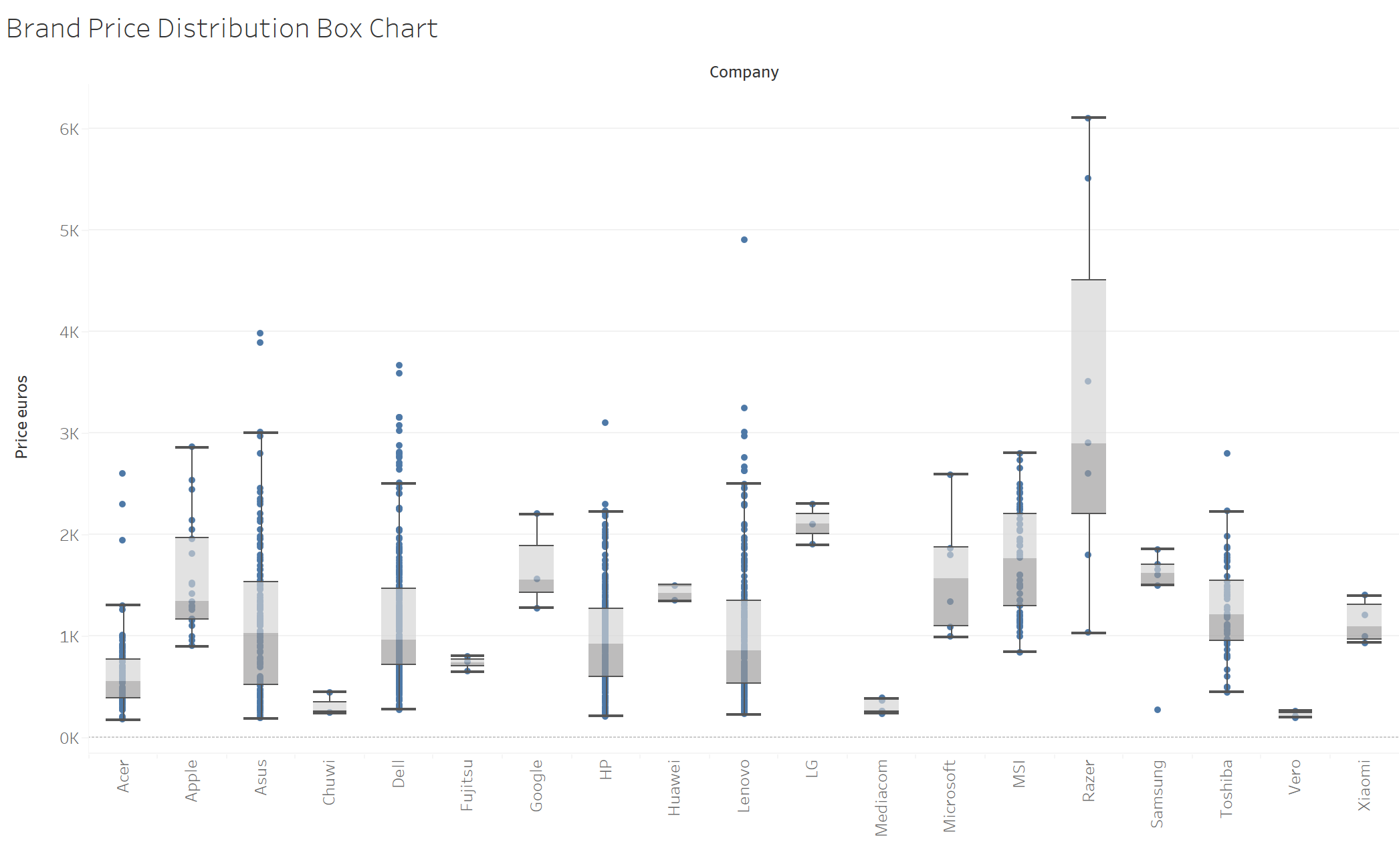

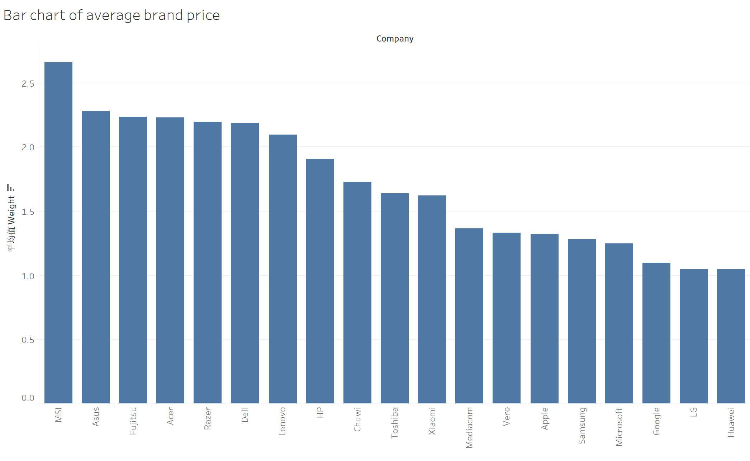

From the pricing distribution of various brands, we can see their competitive positioning in the market. MSI and ASUS have both the highest average product prices and a wide range of product price distributions, indicating that they are the industry leaders in the notebook market at this time.

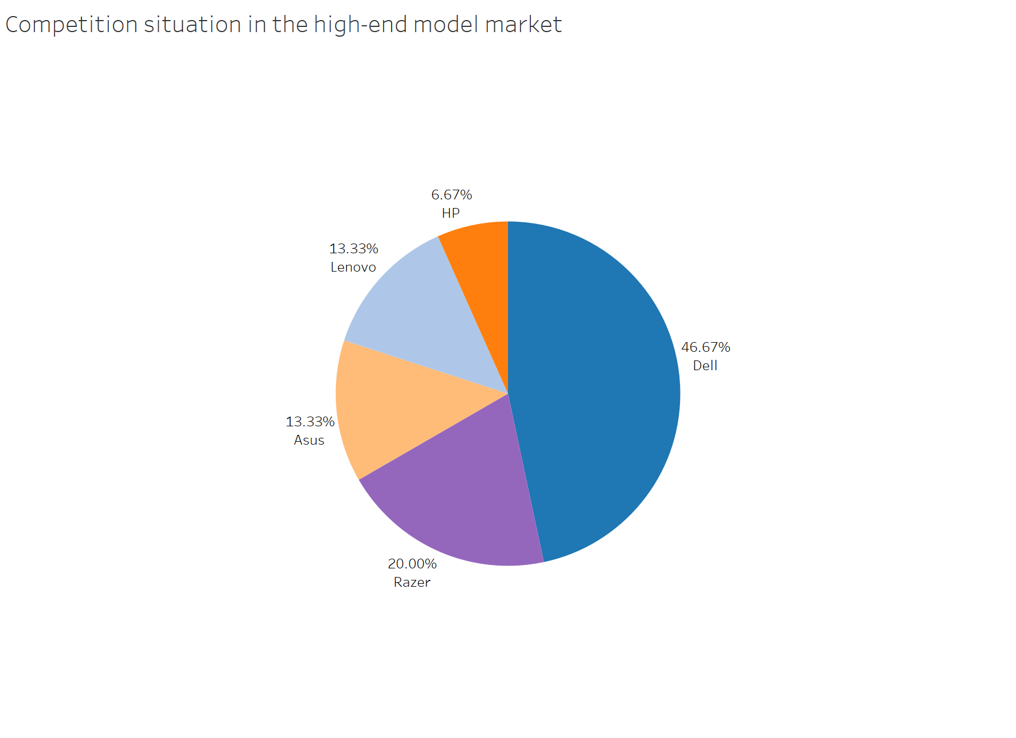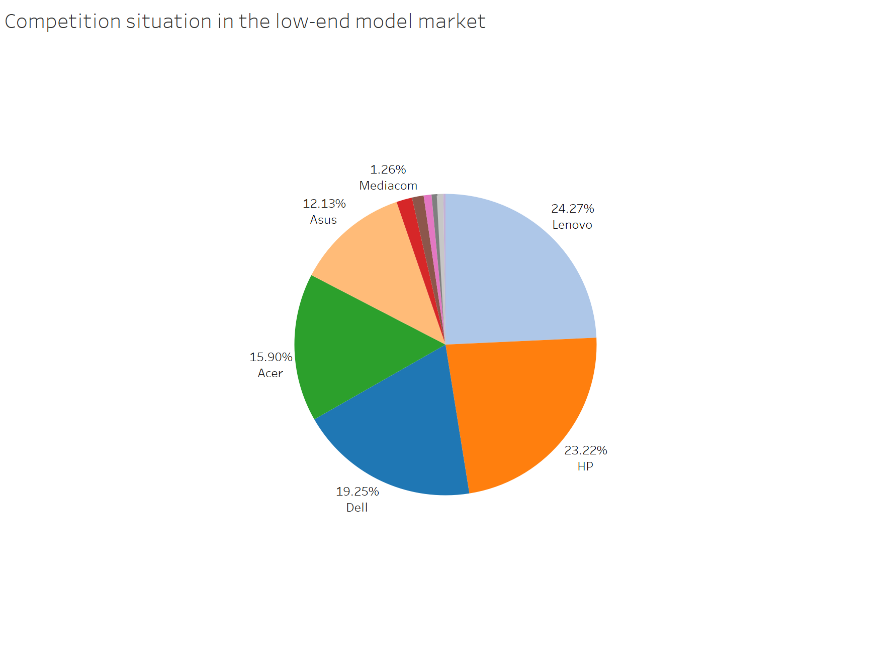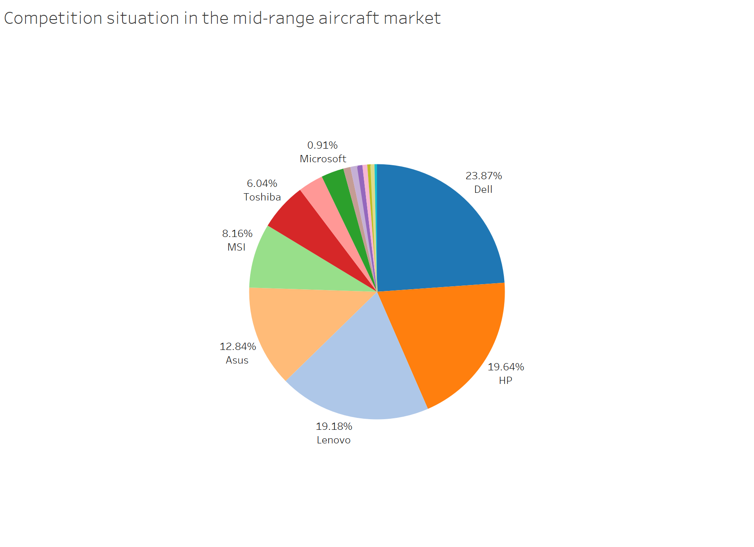

Divide the market into three levels: high, medium, and low-end, with 800 and 3000 as the dividing lines. By observing the investment situation of enterprise products in each market, it can reflect the distribution of main competitiveness and the degree of investment.

In these three pictures, Dell, Lenovo, and HP, as large manufacturers, rightfully occupy a significant proportion. They are making a full push in the entire notebook market. Razer and Acer occupy a place in the mid to high end market. Although Asus may not have as many products as the three giants, it still ranks high in every market.

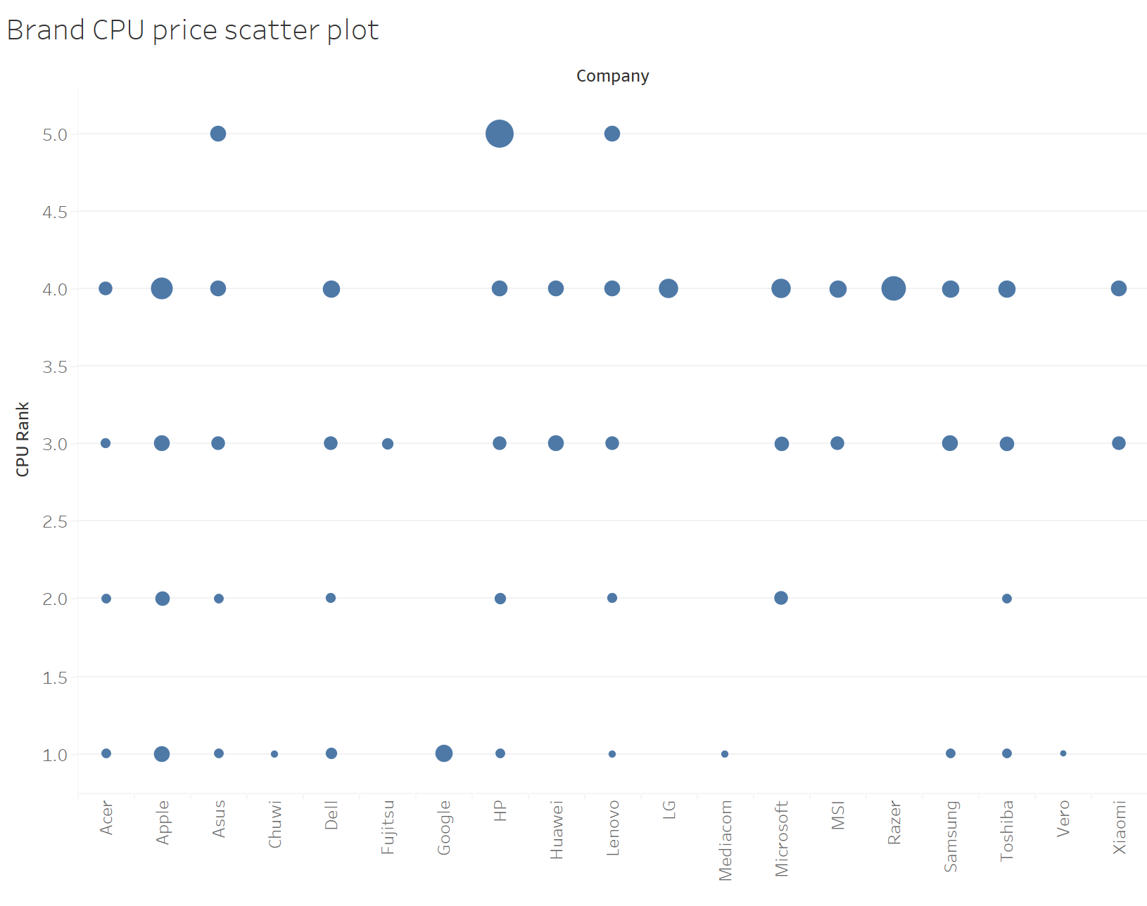

The brand CPU price chart provides support for the previous analysis from the perspective of product strength. Often, higher end laptops are paired with CPUs with better performance and higher prices. There are also some brands that enhance product added value through brand effect, such as Apple and Google.

### Analysis from the product parameters

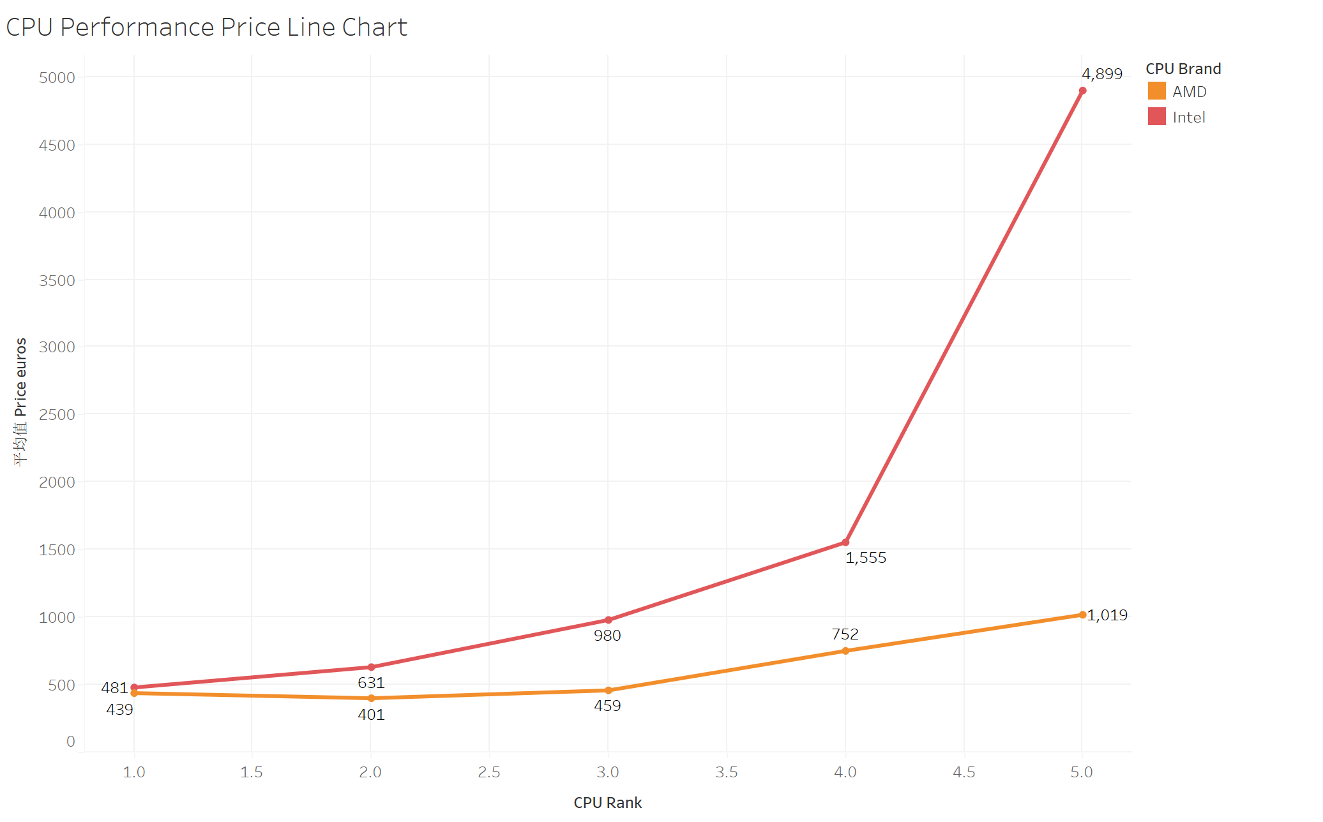

Overall, the higher the performance of the CPU, the higher the product price. We also noticed that products using AMD CPUs of the same level are priced lower than those using Inter CPUs. This situation becomes increasingly significant with the improvement of CPU performance.

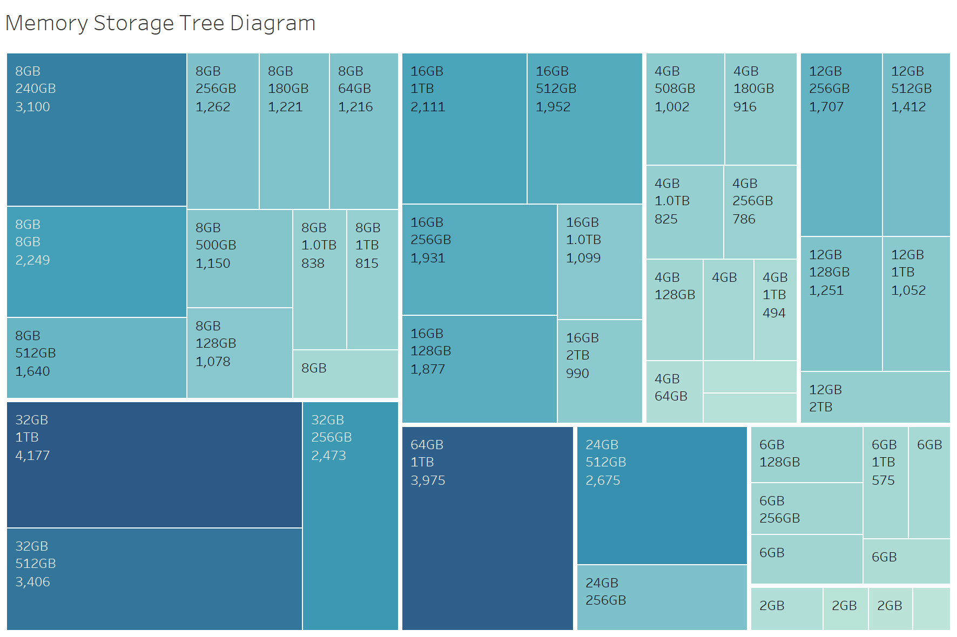

Compared to storage, memory has a greater impact on price. And in terms of capacity size changes, the increase from medium capacity to large capacity is much greater than the increase from small capacity to medium capacity.

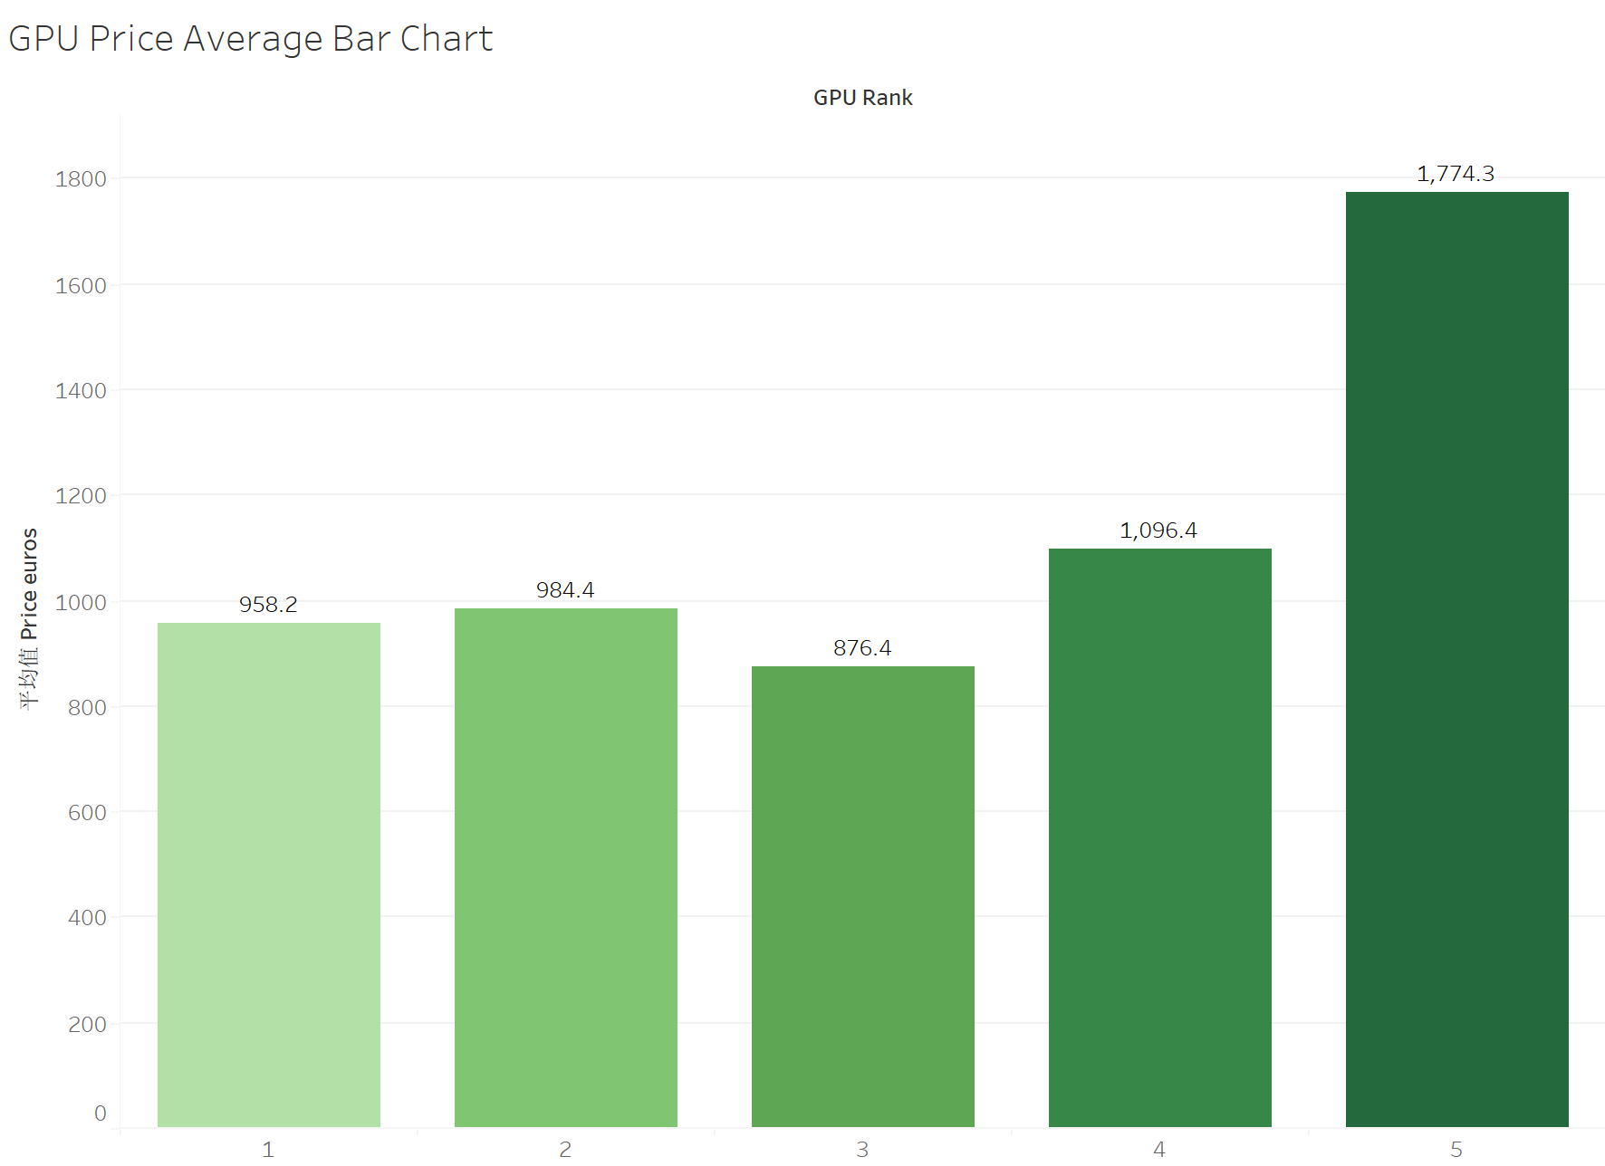

In terms of GPU, the price difference between the first four tiers is not significant, while the fifth tier is much ahead. This situation may be caused by the small internal performance variance of integrated graphics cards and the significant performance difference between them and independent graphics cards.

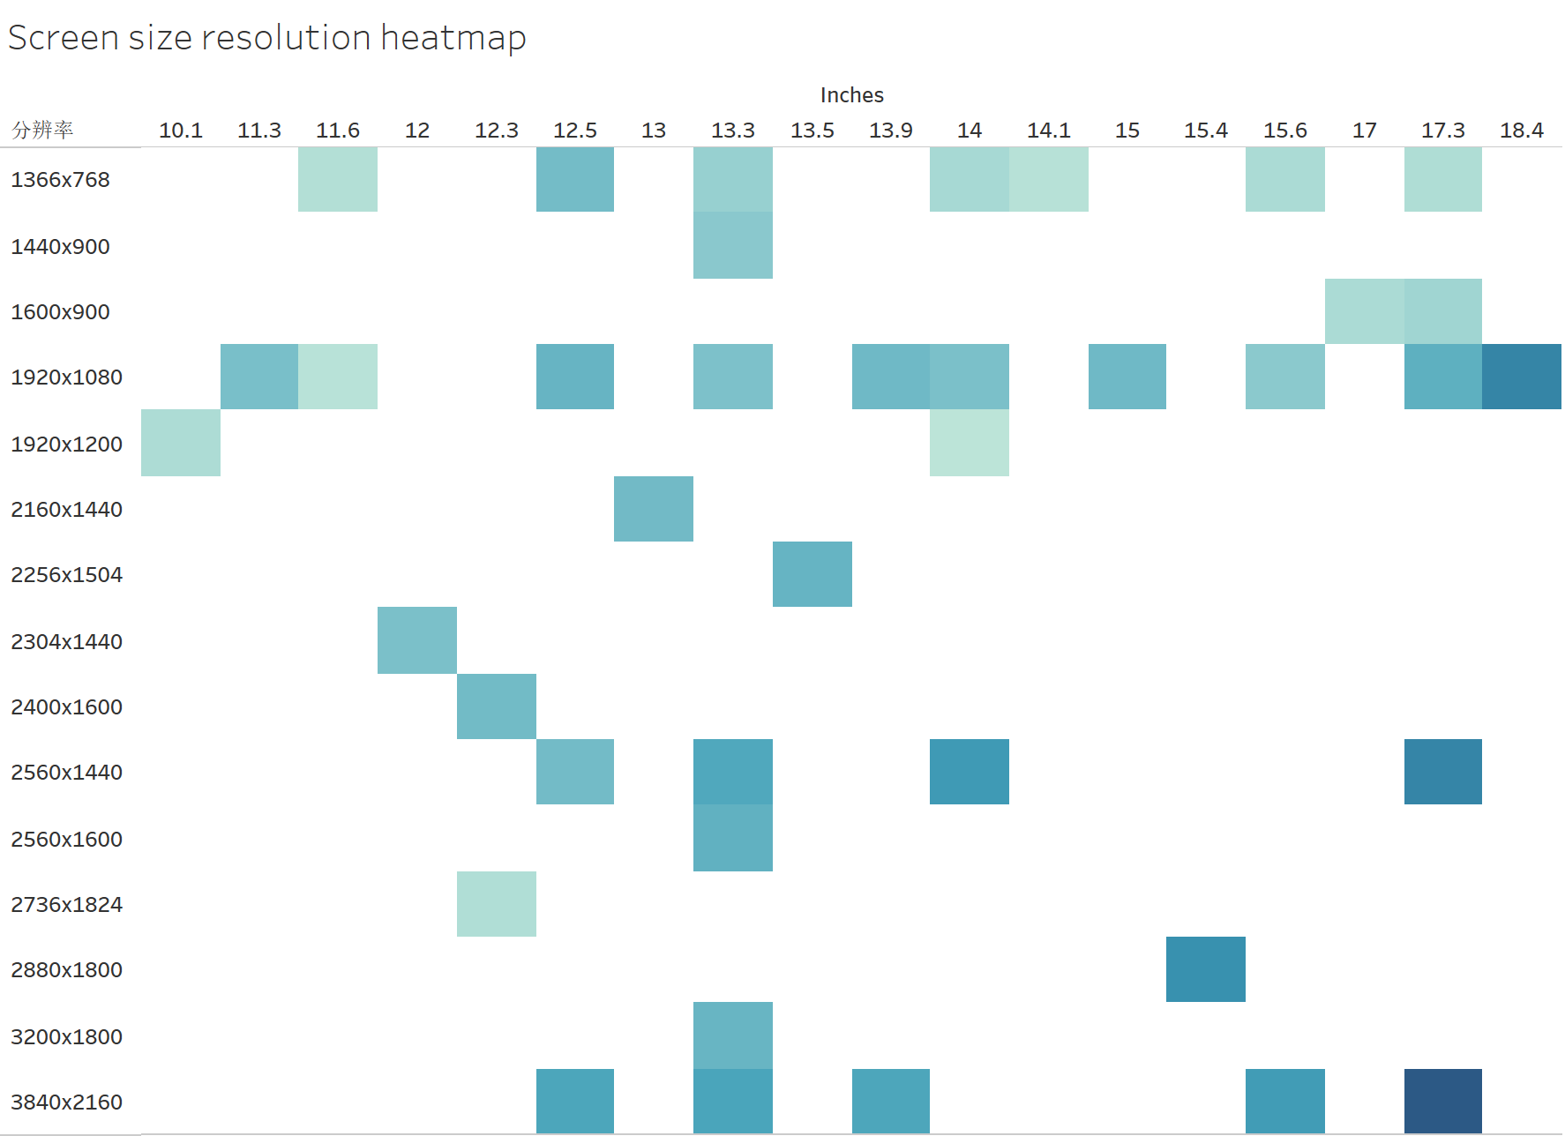There is a trend of higher prices for screens with larger screens and higher resolutions. Of course, we also need to consider the irrationality of applying high-resolution to small screens and low resolution to giant screens.

### Regression analysis of price influencing factors

Use R to perform regression analysis on prices for each variable, and the results are shown in the table below.

|  |  |  |  |  |
| --- | --- | --- | --- | --- |
| Variable Name | Coefficients Estimate | Std. Error | t value | Pr(>|t|) |
| Company | 626.78 | 63.43 | 9.881 | < 2e-16 |
| TypeName | 1282.40 | 50.01 | 25.642 | < 2e-16 |
| Inches | 621.78 | 204.48 | 3.041 | 0.00241 |
| RAM | 1239.44 | 89.74 | 13.811 | < 2e-16 |
| Weight | 673.19 | 61.05 | 11.026 | < 2e-16 |
| resolution | 546.36 | 31.71 | 17.228 | < 2e-16 |
| Screen | 575.43 | 32.63 | 17.637 | < 2e-16 |
| CPU_Brand | 659.00 | 687.97 | 0.958 | 0.338 |
| CPU_Rank | -17.52 | 49.08 - | 0.357 | 0.721 |
| GPU_Rank | 617.28 | 41.55 | 14.86 | <2e-16 |
| Memory1_Size | 776.45 | 179.95 | 4.315 | 1.72e-05 |
| Memory1_Type | 507.81 | 68.49 | 7.414 | 2.2e-13 |

Brand, laptop type, storage, weight, screen, GPU have a significant impact on price, with laptop type and memory having the highest regression coefficients and a significant influence on price.

## Conclusion

By analyzing the data, we have gained some insights into the notebook market. Dell, Lenovo, HP, MSI, and ASUS are all outstanding players in the industry with a large number of product launches.

When choosing a computer product, it is best to first select the laptop type according to your needs, and then choose GPU and RAM, as these factors have a significant impact on the price. This is also true for product development, as these factors will largely determine the positioning and pricing of the product in the market.